1. It showed “No activity” when I first opened it. 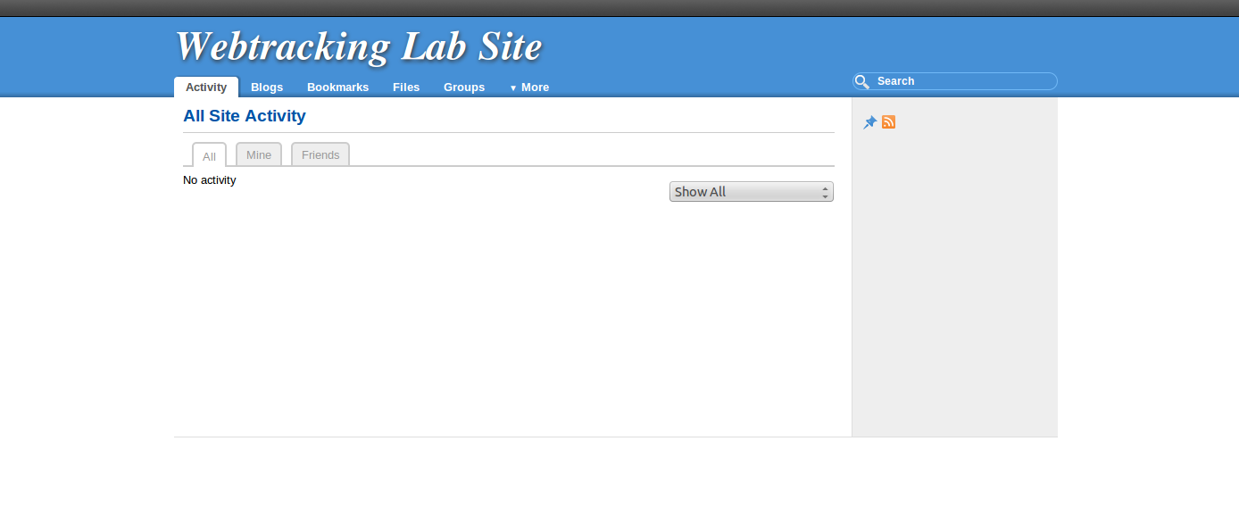
2. After visiting the four stores and refreshing the elgg website, it showed the history where I visited, and pictures of products that I have clicked into. 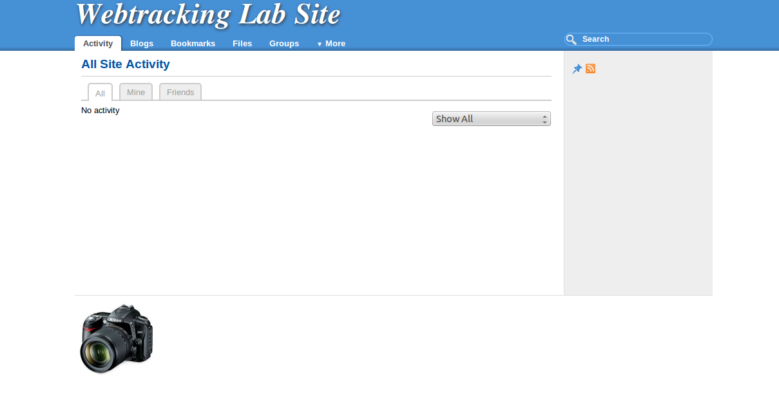
3. 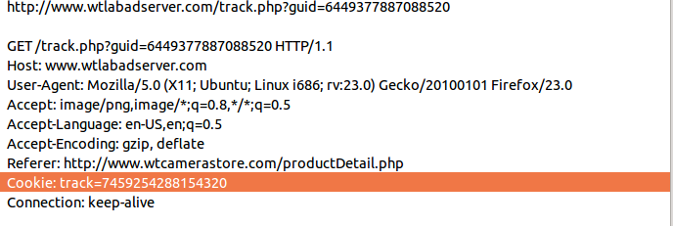
4.  It gets the cookie from the link
5. 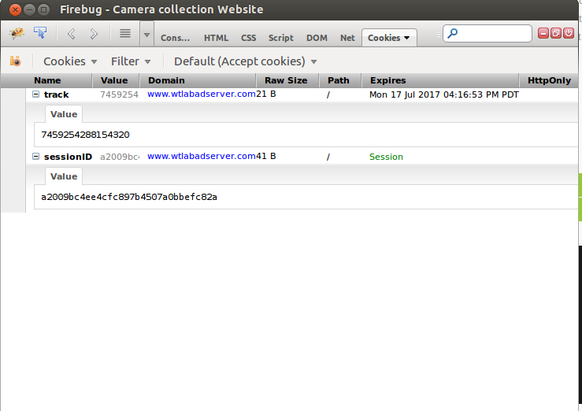 No records on the product webpage, only labadserver
6. 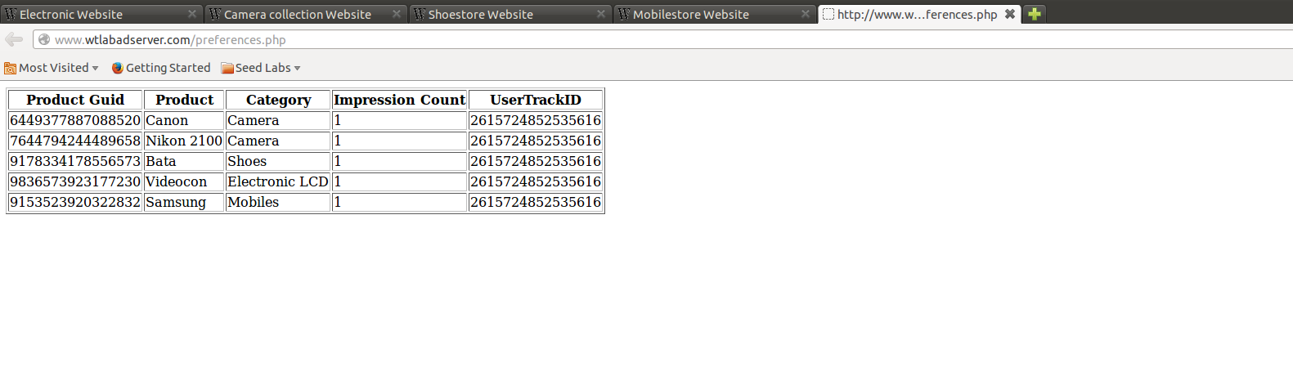 It tracks the number of clicks users have on different type, brand of products. Which one has the best number of impression count will be the ad to post on the website.
7. 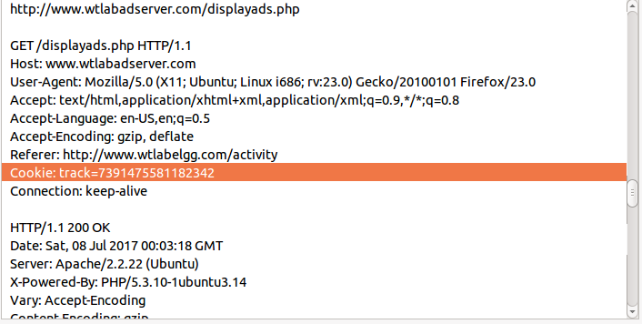 It comes from the labadserver.
8. 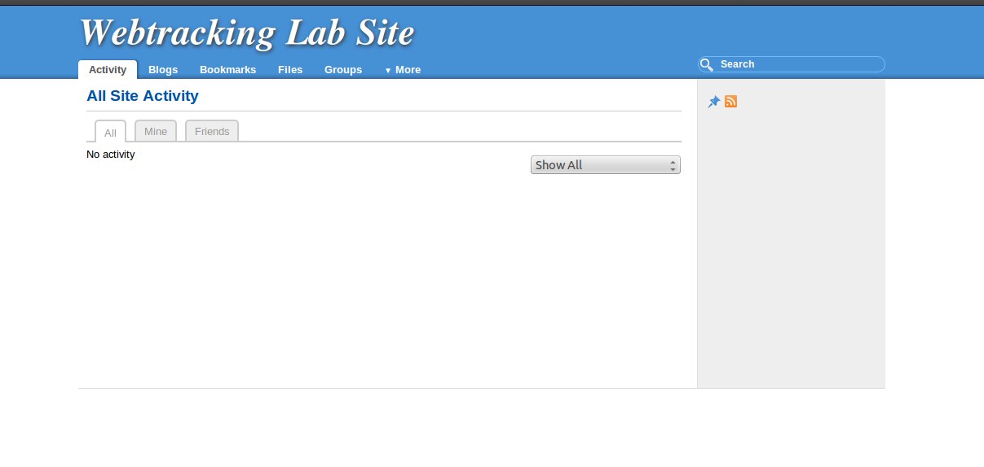No activity when first opened a private window.
9. 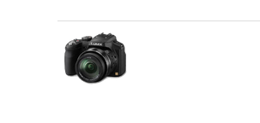 It showed the recent activities.
10. After closing the private window and reopen it, it showed no activities again, which means that the private window cleared the cookies and history when it is closed, while the cookies and history are kept using normal window.
11. 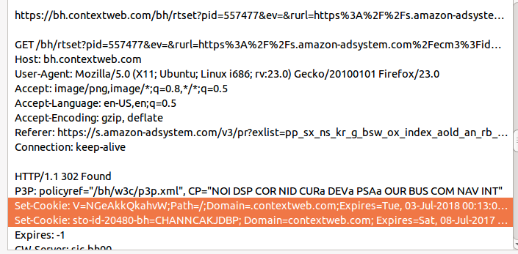 Amazon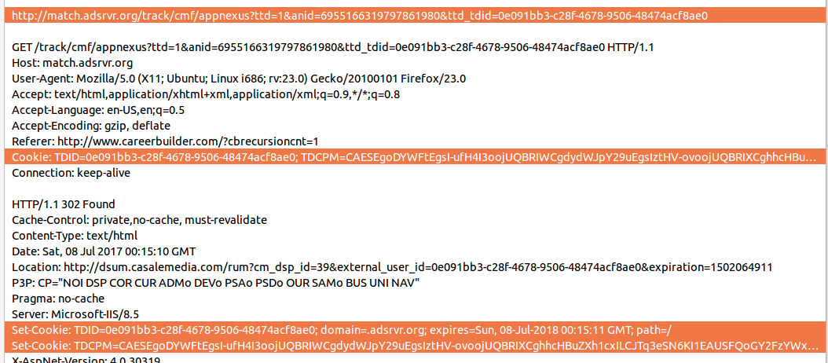Career Builder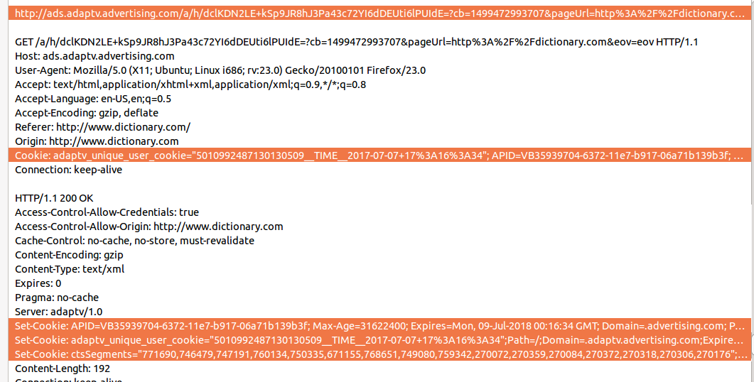Dictionary
12. 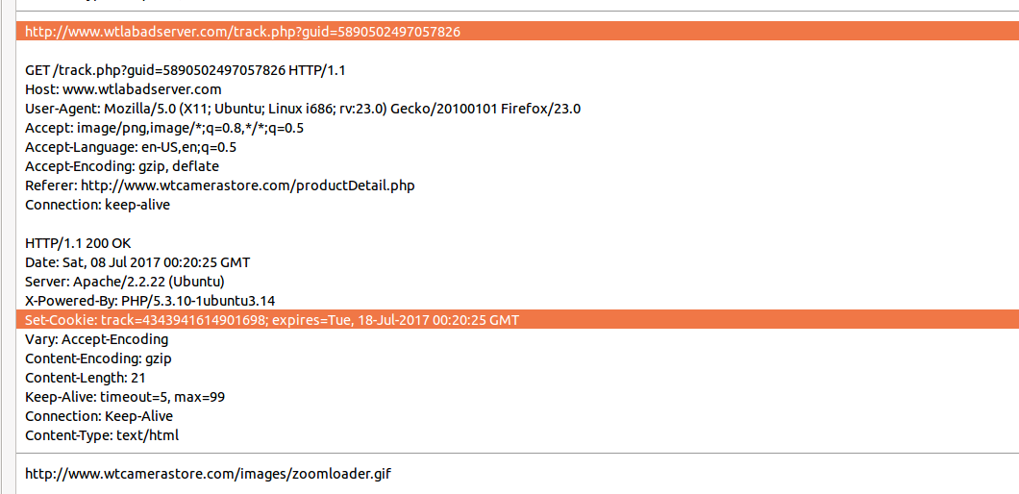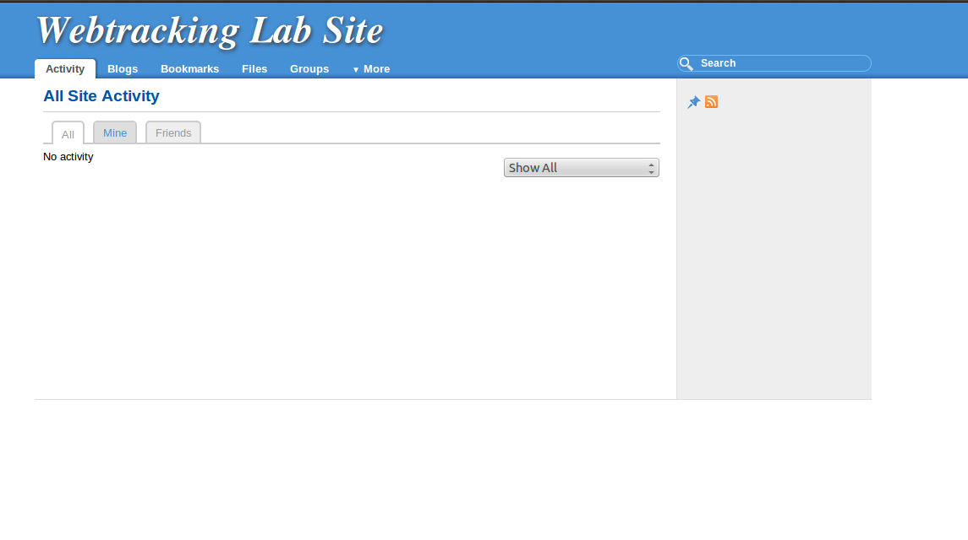It showed nothing this time. 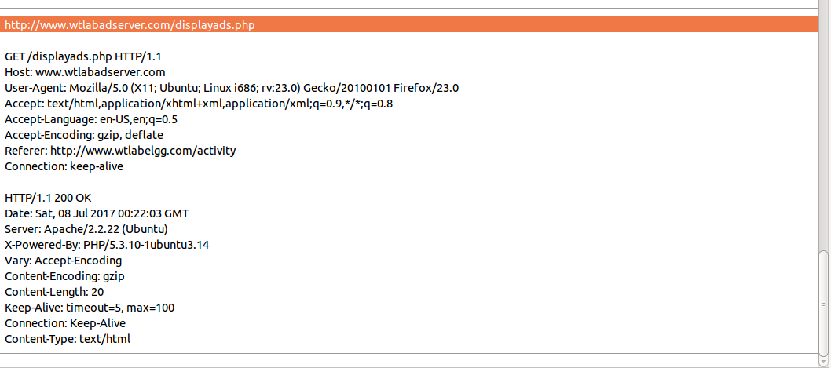No “cookie: track” line this time. No set of cookie.